view that shows year-by-year profit.

The Data Source page shows the sheets or tables in your data.

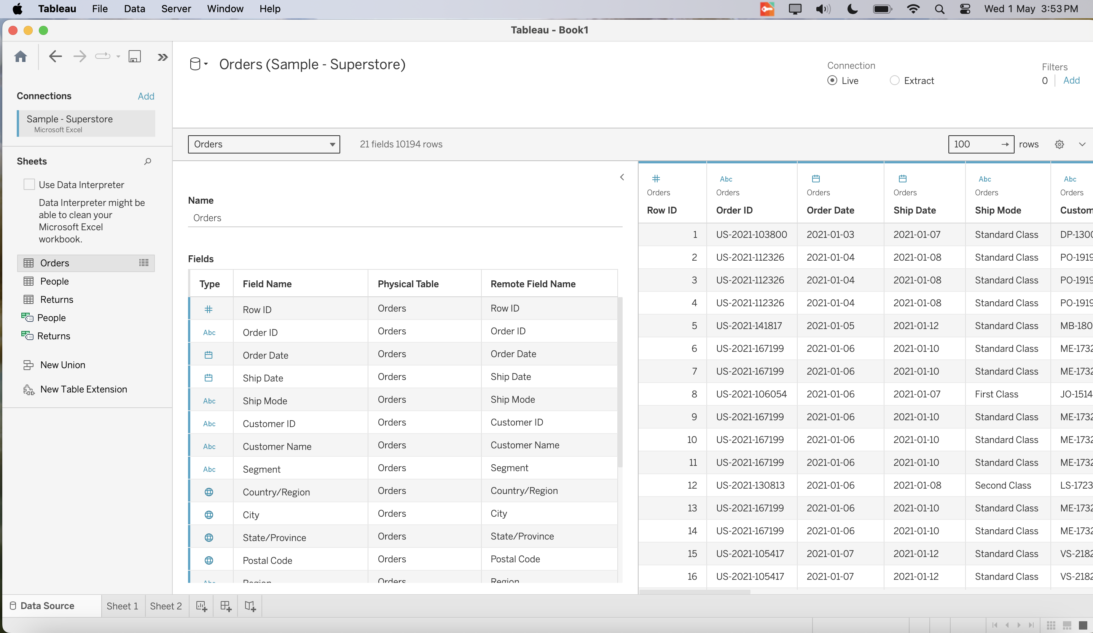

The resulting table has four columns and one row. Each column header represents a member of the Order Date field (the default date level is YEAR). Each cell contains an “Abc” label, which indicates that the current mark type for this view is text.

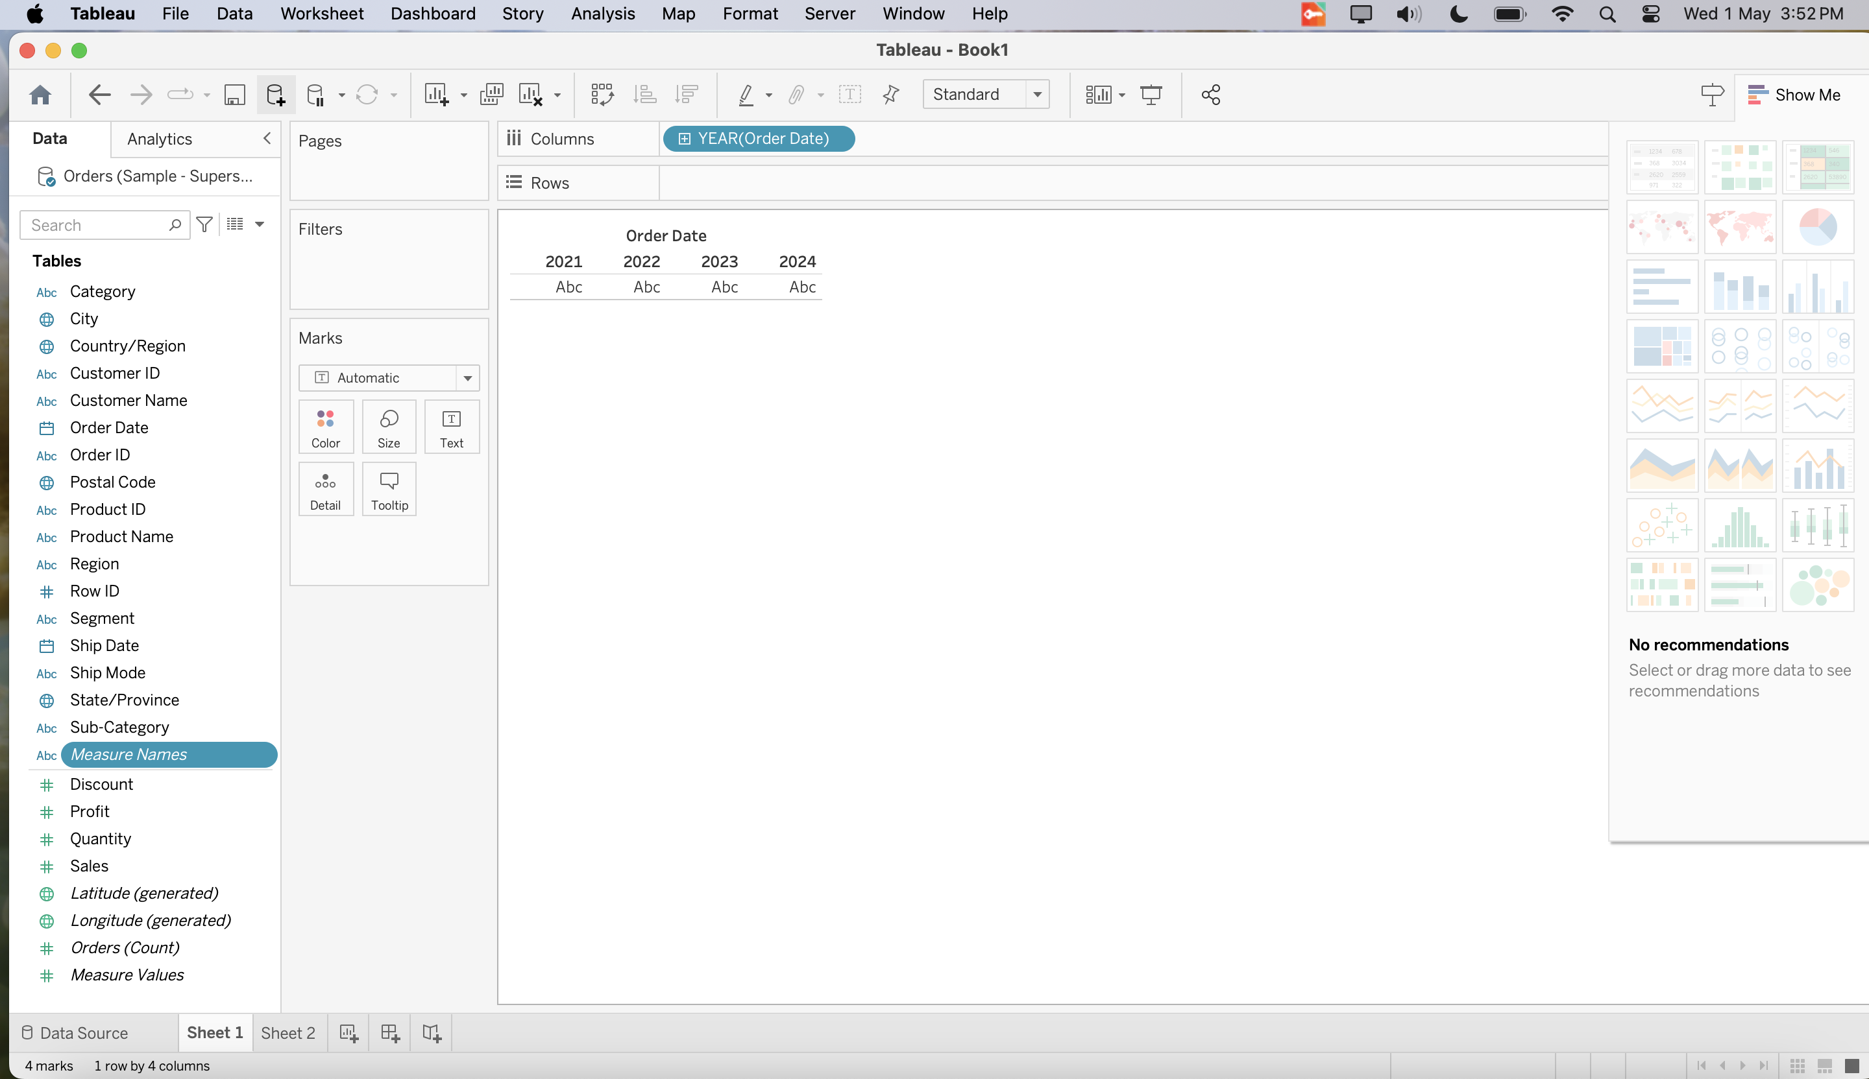

Tableau transforms the table into a line chart and creates a vertical axis (along the left side) for the measure.

A line chart is a great way to compare data over time and identify trends effectively.

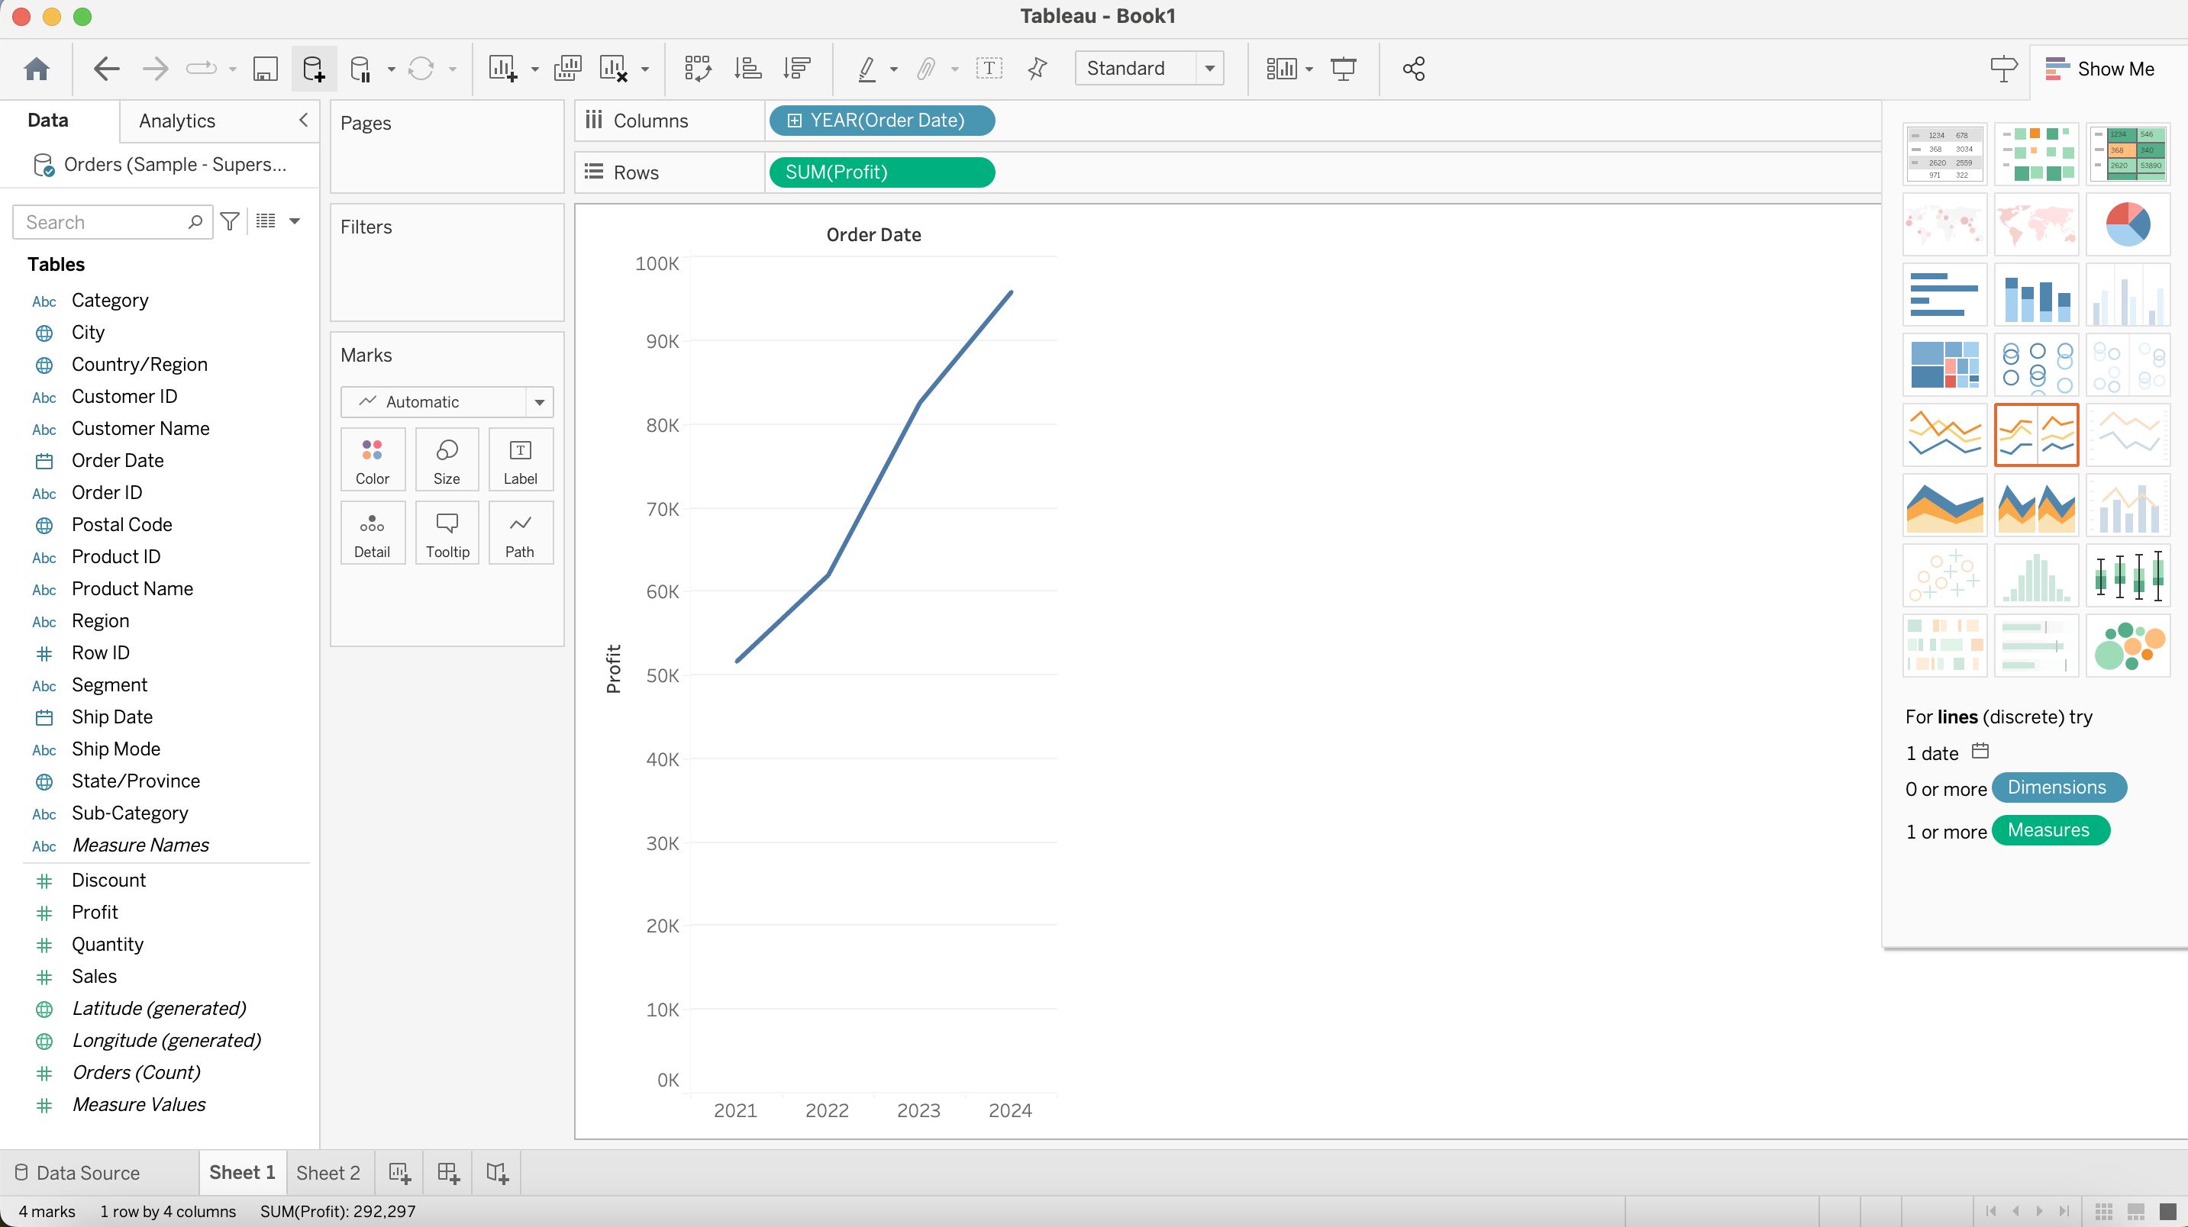

The new dimension divides the view into separate panes for each year. Each pane, in turn, has columns for quarters. This view is called a nested table because it displays multiple headers, with quarters nested within years.

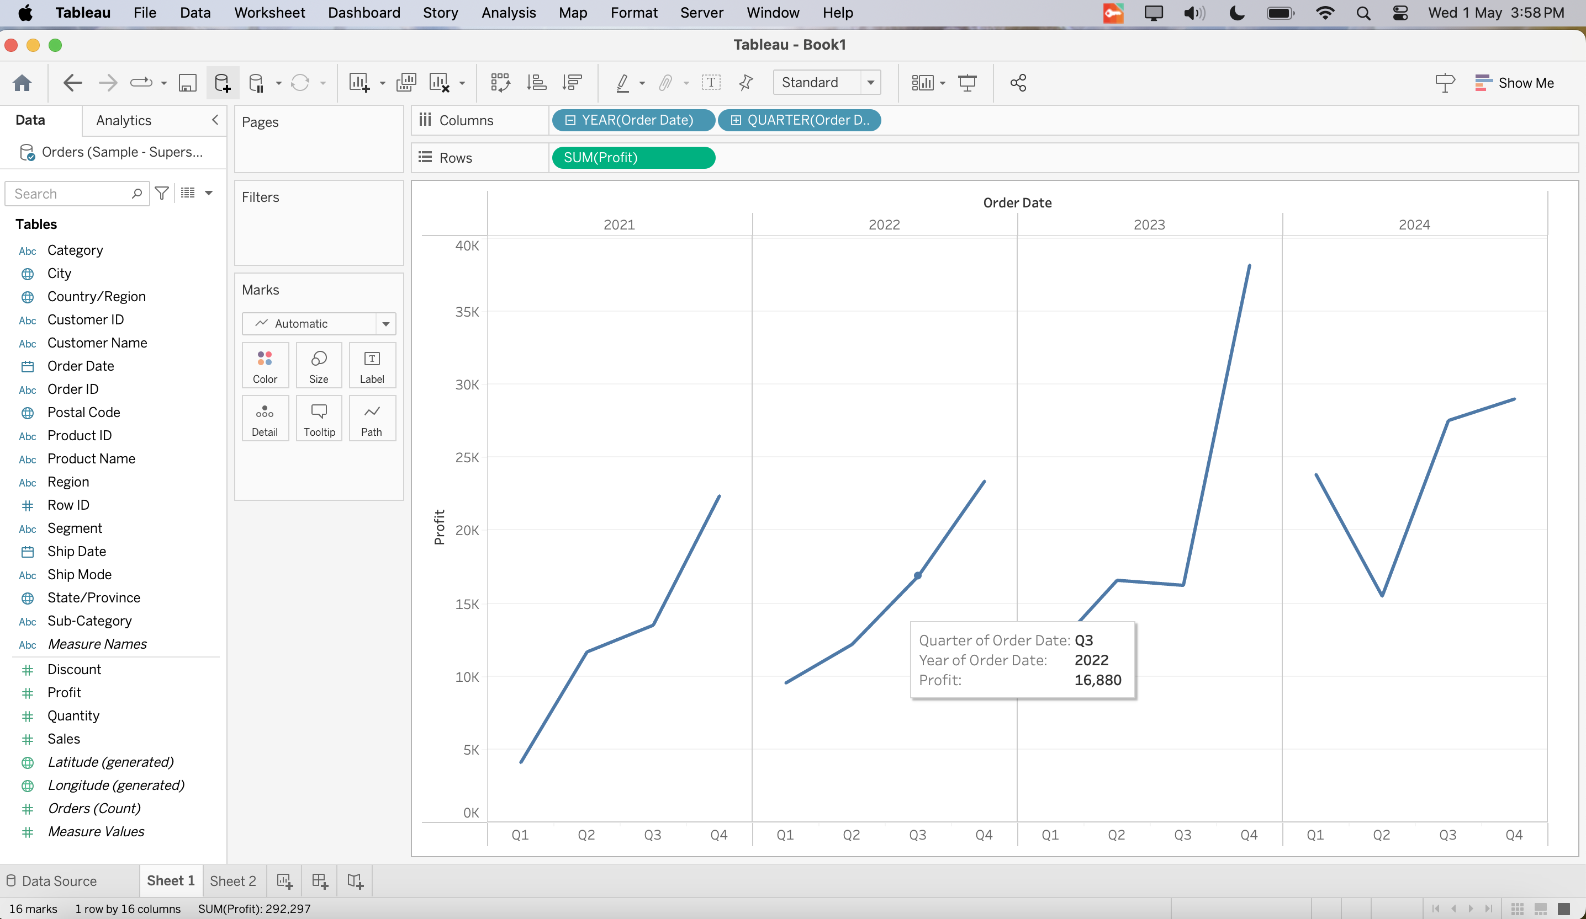focus your exploration by only showing a subset of the data,

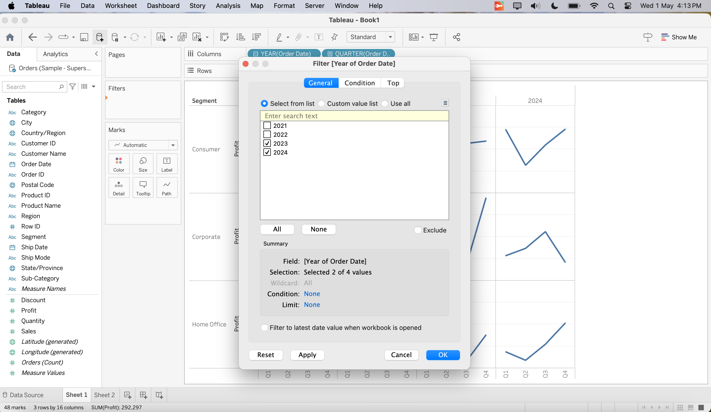

## Marks card to add depth to the analysis

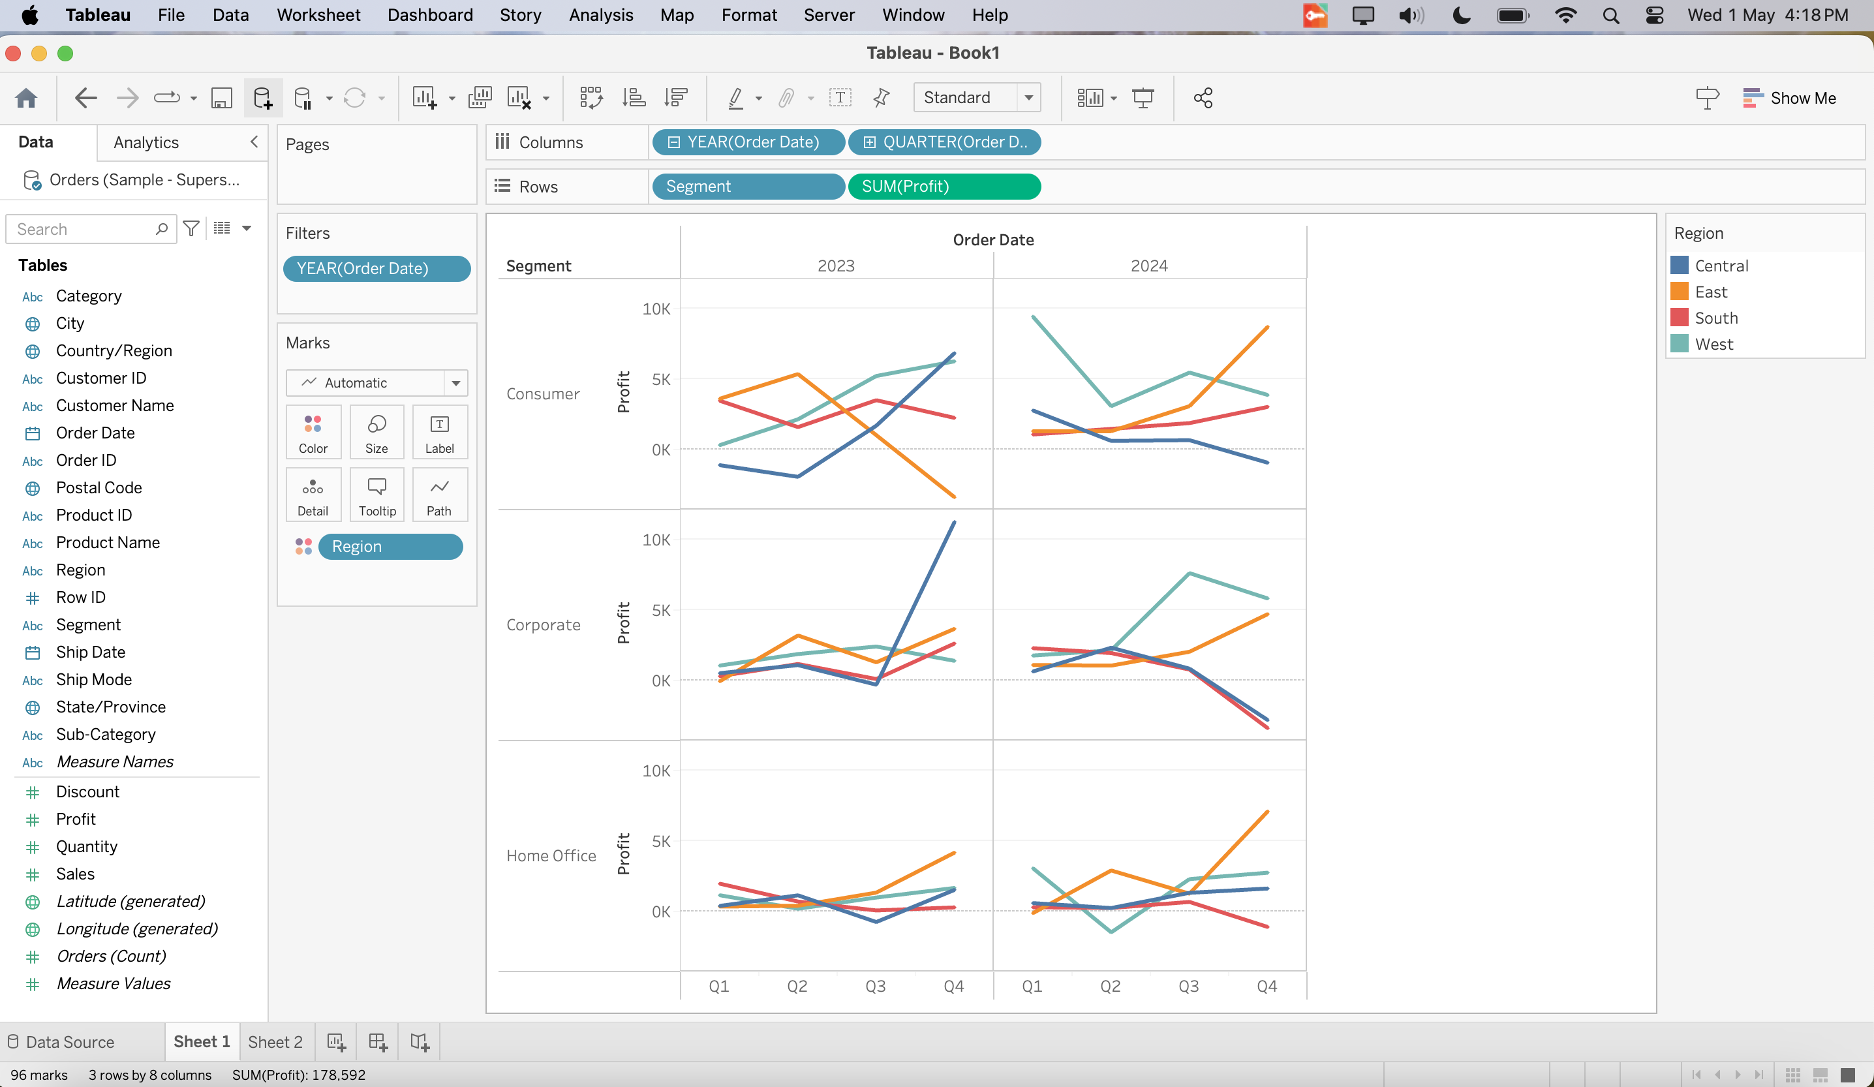

The view now shows profit for each customer segment and region for 2018 and 2019.